**Attention!** To complete the test tasks, download and open the data array using the link:

[Копия Данные для тестового задания](https://docs.google.com/spreadsheets/d/1TB8gc40MtI4SK0pwo2XOg0o51OHYTSujBjYK7rKlWm4/edit?gid=1687485228#gid=1687485228)

1. In the "Audience Data" tab, information about users who visited our app in November. What is the MAU of the product?

*MAU (Monthly Active Users) is a metric used to measure user activity for one month. It shows the number of unique users who have interacted with a product, service, or application at least once in the last month.

7639

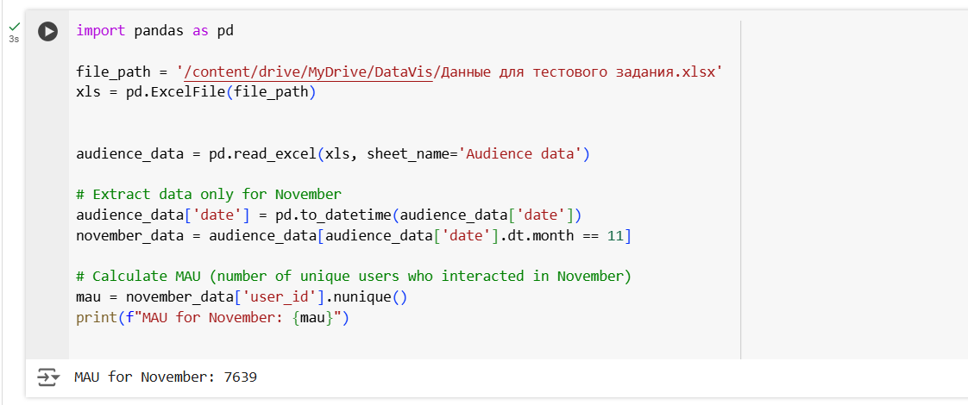

2. Using the "Audience Data" tab, calculate what the DAU will be.

*DAU (Daily Active Users) is a metric that shows the number of unique users who have interacted with a product, application, or service at least once during the day. DAU helps to understand how many users actively use the product every day.

560



3. Using the "Audience Data" tab, calculate what the first-day retention rate will be for users who joined the product on November 1st.

*Retention is a metric that shows how many users continue to use a product after a certain period following their initial interaction. Retention can be calculated as the percentage of users who returned to the product after a specific time (e.g., after 1 day, 1 week, 1 month) out of the total number of new users.

26,6%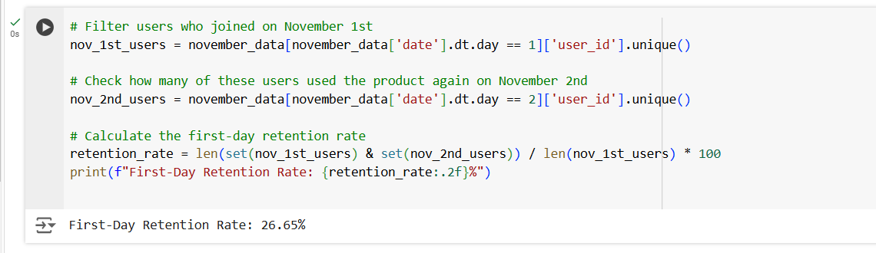

4. On the graph, there are retention curves for two products. What conclusions can be drawn by looking at them?

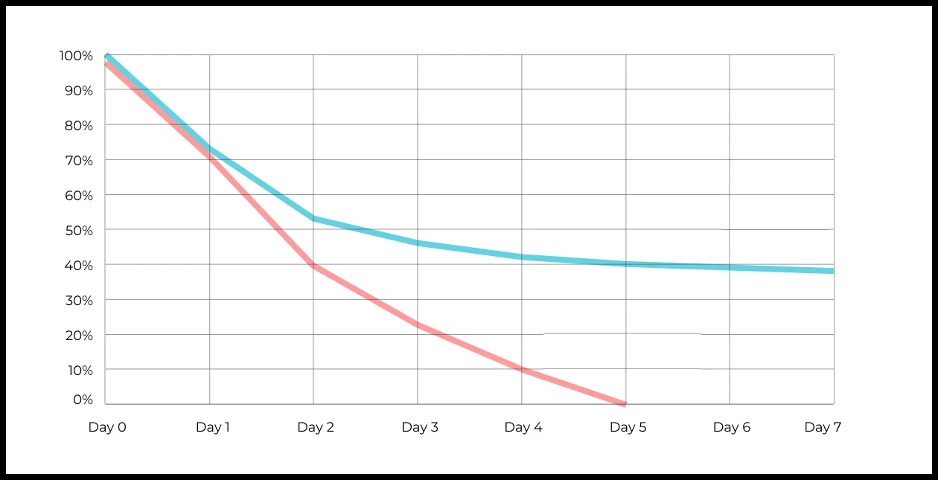

Your answer:

5. In the "Audience Data" tab, there is information about how many ads each user has viewed (view_adverts). Do you calculate the user conversion per ad view for November? (in users)

* User conversion is a metric that shows what percentage of users completed a target action relative to the total number of users. In the context of websites, this can be an action such as viewing an ad or clicking on an advertising banner.

46,3%

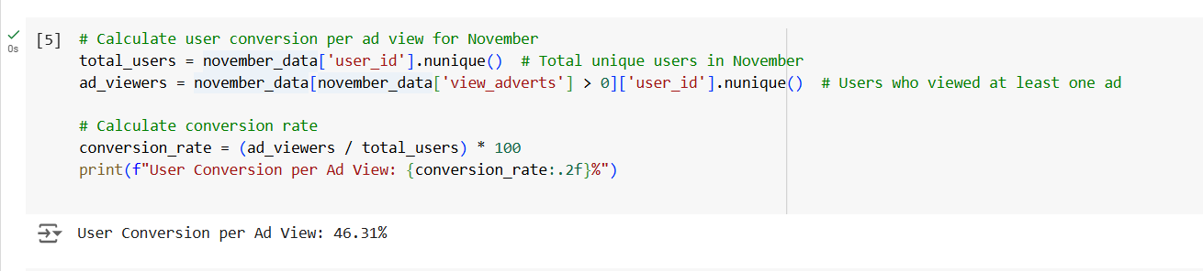

6. Using the information from the Audience Data tab, calculate the average number of ads viewed per user in November

2,9

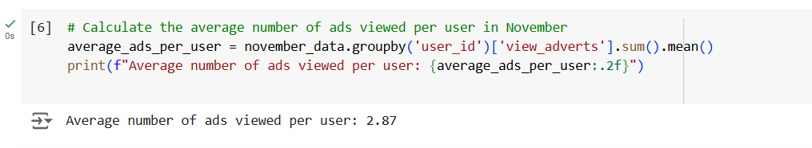

7. We conducted a survey among 2,000 users. Of them, 500 are "critics," 1,200 are "promoters," and 300 are "neutrals." Calculate the NPS.

*NPS (Net Promoter Score) — is a metric that measures user loyalty towards a company or product and categorizes them into three groups: Promoters, Passives, and Detractors. NPS is calculated as (% of promoters - % of detractors).

35%  
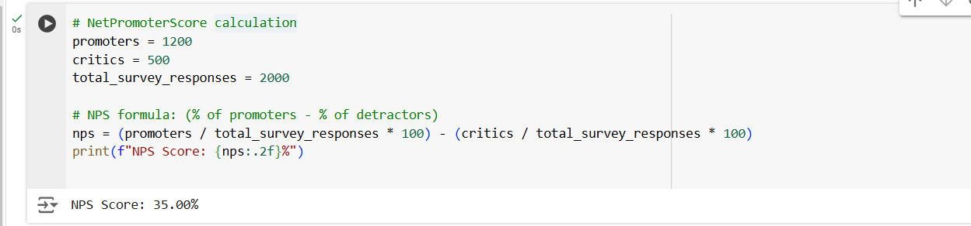

8. In the "AB Test Data" tab, there are results of three unrelated AB tests for ARPU (total revenue/total number of users).

1. **Look at the test results and interpret them.**
2. **Write down the p-values you obtained.**
3. **Prepare conclusions and recommendations.**

**Data Columns:**

* **experiment_num**: Experiment number
* **experiment_group**: Group the user was assigned to
* **user_id**: User ID
* **revenue**: Revenue generated by the user through purchasing a paid promotion service.

Your answer:

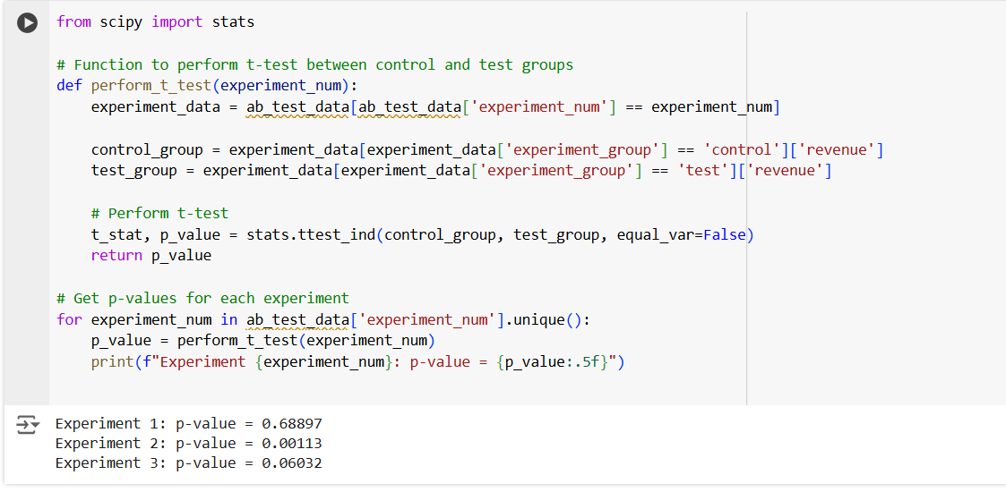

### Experiment 1:

* p-value: 0.68897
* Conclusion: There is no statistically significant difference between the control and test groups. The p-value is much greater than 0.05, which means the changes introduced in the test did not have any noticeable impact on user behavior or revenue (ARPU).
* Recommendation: Since the test did not show any significant improvement, it’s not advisable to implement the changes. Consider revising the hypothesis, adjusting the experiment parameters, or testing a different feature.

### Experiment 2:

* p-value: 0.00113
* Conclusion: There is a statistically significant difference between the control and test groups. The p-value is much smaller than 0.05, indicating that the test group had a meaningful impact on ARPU. Given the low p-value, the changes introduced likely had a positive or negative effect on user revenue, depending on the direction of the results (higher or lower ARPU in the test group).
* Recommendation: Assuming that the test group outperformed the control group, you should implement the tested changes for all users. If the test group performed worse, further investigate why the changes negatively affected revenue and consider modifying or scrapping the feature.

### Experiment 3:

* p-value: 0.06032
* Conclusion: The p-value is slightly above the 0.05 threshold, which means there is no statistically significant difference between the control and test groups. However, it is very close to significance, suggesting that the test may have had a weak effect on user behavior or revenue, which might not be large enough to reach statistical significance in this sample size.
* Recommendation: Since the result is borderline, it may be worthwhile to either:
  + Rerun the experiment with a larger sample size to determine if the effect becomes statistically significant, or
  + Review the feature and consider tweaking it to enhance its impact on ARPU before retesting.

9. Calculate the average income per user based on the dataset with the listers

156.4

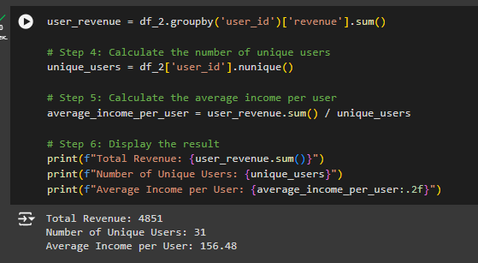

10. Based on the dataset with the listers, calculate the median age of the user

28

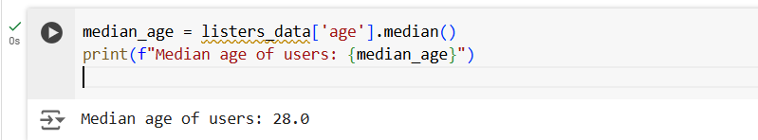

11. Which chart is best suited to display the spread of prices for goods in different stores?

*There may be several possible answers.

Box with whiskers (box plot) The histogram  
**Box plots** show the **distribution** of data, including the **median**, **quartiles**, and **outliers**.

12.What is the bimodal distribution graph?

№3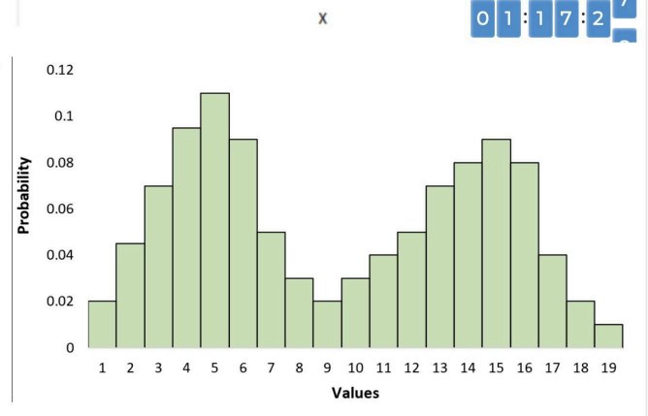

13. Which random variable has the largest data variance according to the following distribution density graph?

№3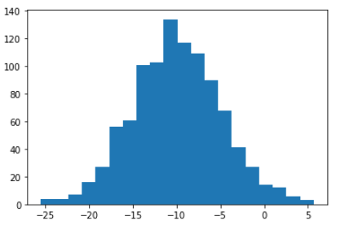

14. On which graph can the correlation be calculated?  
\**There may be several possible answers.*

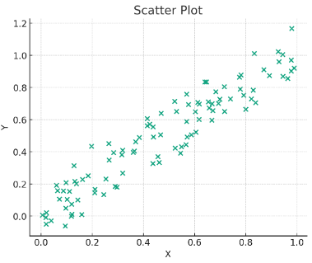

15. What does it mean if, when testing hypotheses, we got p-value = 0.05?

There is a 5% chance of accidentally getting this or an even more extreme result if the null hypothesis is correct

16. Which method is most suitable for testing the hypothesis of equality of the average of two samples from a normal distribution?

t-test

17. How to interpret quartiles in the distribution of user income?

Divide the data into four equal parts

18. The following results were obtained. Colleagues ask you to confirm them and make a final conclusion on the experiment.

* + - * Option A (control group) — 100,047,501 visitors, 1003 payments.
      * Option B (test group) — 100,001,055 visitors, 1099 payments.

What recommendations would you make based on this data?

Your answer:

Although the difference in conversion rates is minimal, with Option B having a slightly higher rate, further analysis is needed to determine if this difference is statistically significant. A statistical test, such as a chi-square test or a z-test for proportions, would help confirm whether this variation is meaningful. If the test indicates significance, Option B could be recommended; otherwise, the difference may not be substantial enough to justify changes based solely on this data.